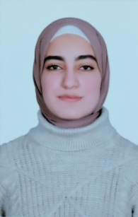

* Drawing
* Reading
* Learning languages
* Art in Science

**Interests**

**Language Skills**

* Arabic: Mother tongue
* English: very good
* French: little
* Turkish: little
* April 2022( current ):Teaching Assistant, Pharmaceutical Analytical Chemistry Department, Faculty of Pharmacy, Menoufia University, Egypt.
* December, 2021- April,2022: Working as a community pharmacist in El-Marwa Pharmacies, Ashmoun, Egypt

**Work Experience**

* January 2023: registration for the master degree studies in Pharmaceutical Analytical Chemistry, Faculty of Pharmacy, Menoufia university.
* 2016 - 2021:Faculty of Pharmacy, Menoufia University, Egypt.
* July,2021:Bachelor of Pharmaceutical Sciences (B.Sc.) (Excellent with Honor, ranked 6th of 360)

**Education**

* Bachelor of Pharmaceutical Sciences (B.Sc.) certificate ( May,2021)
* FIRST AID & CPR TRAINING COURSE ACHIEVEMENT CERTIFICATE FROM EMSA (February, 2017)
* SEDICO TRAINING ACADEMY CERTFICATE ( August,2017)
* Certificate of attending Career Counseling Program conducted in Menoufia Pharmacists Syndicate (July,2018)
* Certificate of attending The First Student Conference of the Faculty of Pharmacy, Menoufia University (APRIL, 2019)

**Certifications**

Email:mennashaaban010@gmail.com

Phone: 01021020919

Address: Ashmoun

Place/date of birth: Egypt, September,10th,1998

**CONTACT**

pharmacist

**Mennat Allah Shaaban**